DGD AND MSDS CHECKING SOP
Fist of all the tool we would like is not reflecting ALL the IMDG CODE which is HUGE and very precise. This tool is to have a quick preliminary look to what customer has provided together with the Mandatory checks ECU is supposed to do and compile with all what Shipping lines has shared to us in the past. (Regular remarks they make concerning wrong DGD and wrong MSDS)
This SOP is for ALL COUNTRIES except if it is mentioned that is only for FRANCE (In yellow)
Once user Upload the documents DGD AND MSDS on the tool, it needs to check the following different paragraphs. Once checked, the tool could show green message showing it has been checked and if OK. Orange, message showing that something is missing or has not be found.
- Presence of Documents: We need to have at least
- 1 DGD
- As many MSDS as UN number mentioned on the DGD. One in each Language needed see paragraph 2.
- For destination ALGERIA: LETTER OF ENGAGEMENT (In French = LETTRE d’ENGAGEMENT) See Appendix 1.
- For destination IVORY COAST only: API document APPENDIX 2 + Letter of engagement example APPENDIX 3. The document must be the SAME format as per MSC shipping line requirement. FRANCE ONLY or any other country using MSC as shipping line.
Message from the TOOL to be mentioned to the user: or
What happens if ALL documents are included : Presence of Document Checked
What happens if one document is missing : Inform user about what document is missing Ex DGD missing
- Language of documents
- DGD
The entire DGD needs to be AT LEAST in ENGLISH included the structure of the DGD (titles of each fields + data entered by customer).
It is accepted if the DGD is written in FRENCH + ENGLISH or Any other language + ENGLISH But it is NOT accepted it ENGLISH is not at all.
Appendix 4 Example DGD with FRENCH and ENGLISH
- MSDS
MSDS but be :
- in ENGLISH (for shipping line)
- in FRENCH (for Local warehouse, this is ONLY for FRANCE)
- SPANISH if the Consignee on the DGD is located in ARGENTINA, BOLIVIA, BRAZIL, CHILE, COLOMBIA, COSTA RICA, CUBA, DOMINICAN REPUBLIC, ECUADOR, EL SALVADOR, GUATEMALA, HONDURAS, NICARAGUA, PANAMA, PARAGUAY, PEROU, URUGAY, VENEZUELA. No need for MEXICO
- PORTUGUES if the consignee on the DGD is in BRAZIL
If the MSDS is needed in several language there will be 1 PDF per language. Example English + French = 2 MSDS PDF.
What happens if Languages are OK : Language Checked
What happens if Language is NOT OK : MSDS in ENGLISH missing
- Accuracy of the documents
- DGD
- Document must be FILLED with at least NAME of company + Name of declarant + SIGNED in the bottom right. It can be filled each fields OR with a stamp, both is OK as long as it is signed in the field SIGNATURE.
Example of DGD correctly signed and filled. This examples are OK because there is a signature of the declarant + the fields are completed (Name of shipper and name of declarant)
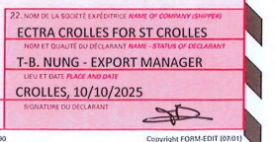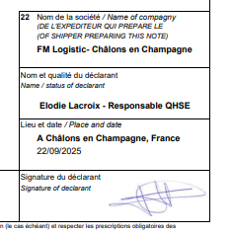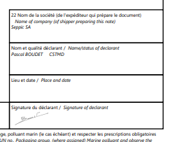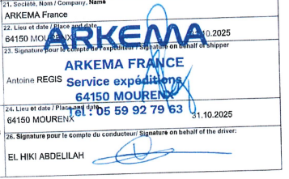

Example of DGD NOT signed: This example is NOT OK because there is no manual signature
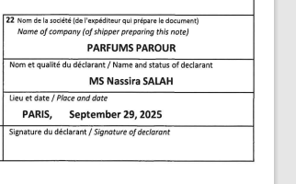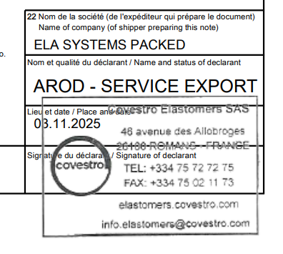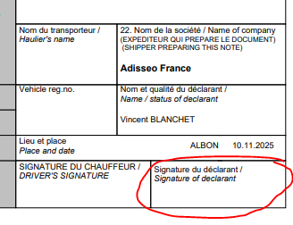
What happens if the DGD seems correct: SIGNATURE CHECKED
What happens if the DGD seems NOT correct SIGNATURE MISSING
- Phone number + NAME (can be name of a person or Contract Number, or Contract name) in case of Emergency needs to be present on the document
Example when all is OK Phone number + Contact person or Contract name
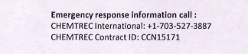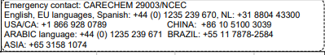
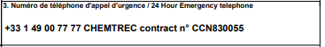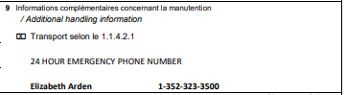
What happens if Phone and Name found: Emergency Phone and Contact checked
What happens if Phone and Name NOT found Emergency Phone OR Contact missing
- Weight of the cargo (GROSS MASS or GROSS WEIGHT, NET MASS or NET WEIGHT) declared by shipper needs to show in Kilos and not in Liters
It can be clearly mentioned KG or KILOS (example left). Or It can also be not mentioned at all (blanck like example on right) but it CAN NOT be mentioned with another quantity, like L or LITERS or LBS, or any other words that means it is not kilos
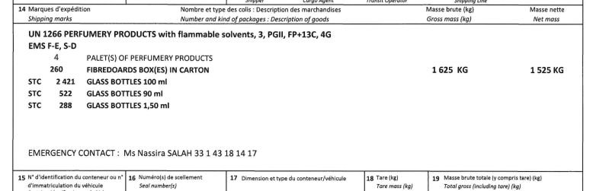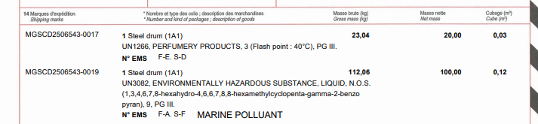
This example is accepted, even though it is mentioned 0.45 L it is in the column that says VOLUME. The columns of NET MASS and GROSS MASS are in KILOS so it is OK for us.
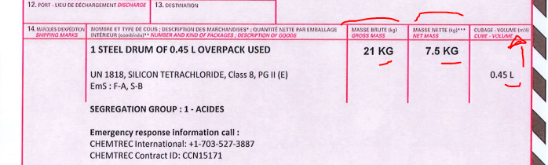

Example NOT accepted , net mass is not in kilos but in Liters.
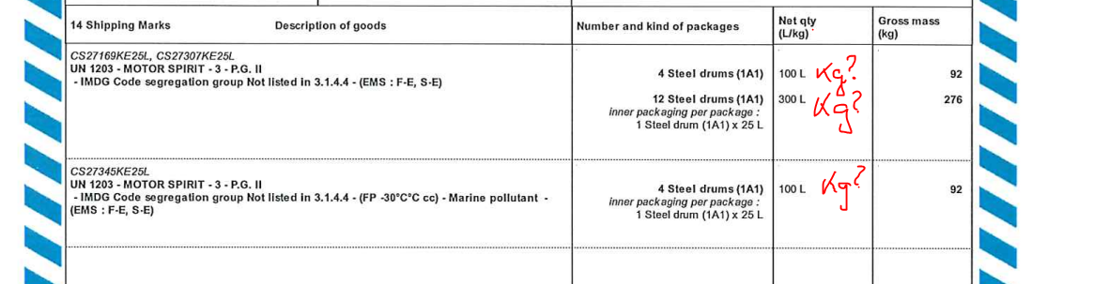

Weight of all the GROSS MASS must always be HIGHER than NET MASS. If Customer show 1625 Gross mass, and 1700 NET MASS = It is not possible. It is also not possible to have SAME gross weight and NET weight (1625 Gross, and 1625 Net is NOT possible)
What happens if Weight is accurate: Weight checked
What happens if there is discrepancy in Weight : Weight issue (Detail the issue, For Example Weight not in KILOS, or Gross Weight </= Net Weight)
- Mandatory basic data to be declared must include:
UN NUMBER (4 digits) Proper shipping name (Name of the UN number) – Technical name (Only if Proper shipping name ends with “NOS” or “NSA” or is MARINE POLLUTANT is mentioned for that particular product only) Class number – Packing group
The ORDER of appearance of that data is supposed to be in that way.
Can be written UN or only the 4 Digits. 4 Digits are listed in the EXCEl sheet provided separately
Name of UN number are listed in the EXCEL sheet provided separately. If a coma is missing, there is no incidence.
Technical name must show in PARENTHESIS if the Proper shipping name ends with N.O.S or NOS or N.S.A or NSA. But it is ALSO mandatory if the terms “MARINE POLLUTANT” or “POLLUANT MARIN” are placed in the same product description. So If Proper shipping name says XXX NOS => Technical name in parenthesis must show. If the proper shipping name say XXX ;;; then same paragraph of same Dangereous description says MARINE POLLUTANT then a technical name must be placed in parenthesis too after Proper shipping name.
Example below Marine pollutant: Technical name in parenthesis is missing. Be carefull what you see below in parenthesis EMS F-e , S-D is not a technical name, this is what you see on Excel sheet Column K. Every thing in parenthesis with Letter-Letter , Letter-Letter is NEVER a technical name.
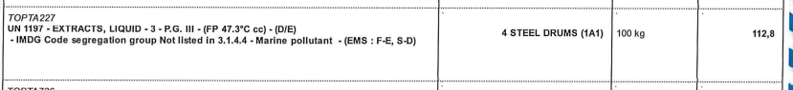
Class number must match with the list provided in EXCEL column F
Packing group is always mentioned with I or II or III. Can also be PG I PG II or PG III. Very rare but possible PG 1 2 or 3
What happens if All is OK : Mandatory basic Data Checked
What happens if one point not OK : Example: “Missing or Incorrect Proper shipping Name” (no match with Excel sheet provided). “Un number Not found” , “Technical name missing in parenthesis while NOS/NSA/MARINE POLLUTANT mentioned”, “order of appearance of mandatory data not in compliance with IMDG CODE”,
- DGD must show the number and kind of OUTTURN packages with his ONU code.
If number of packages are PALLETS only it is not sufficient. It must show WHAT is on the PALLETS. (FIBERBOARD BOXES, DRUMS, JERRICANS, etc). See Appendix 5 with the list of kind of package accepted, together with their Packing code (ONU code).
If DGD has BOXES (One code starting with 4…) shipping line will probably request what is INSIDE the boxes. Example 4 pallets of 260 boxes, of 2421 bottles. The material of the bottles must also be precised. Example Plastic bottles, Glass bottles, etc
See Appendix 6 of what is Inner packing can looks like.
Example below is all OK
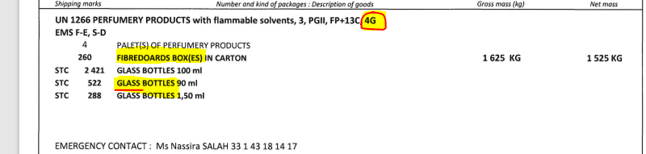

Example of packing code missing. “Steel drum” could be 1A1 or 1A2, not mentioned on the DGD.
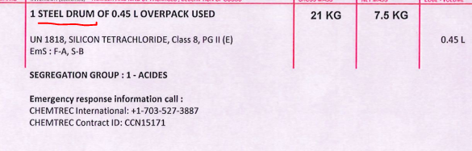

What happens if Packing code found for EACH dangerous goods : Packing code Found
What happens if Packing code NOT found for EACH dangerous goods : Packing code NOT found
What happens if 4G is mentioned but no description of what is INSIDE the boxes : inner packing might be missing
What happens if inner packing is mentioned without the MATERIAL of the inner packing: Inner packing might be incomplete

- In case of Class 3 (See Column F of Excel sheet, or the DGD itself, then the FLASH POINT must be mentioned in degres. A flash point must be a number. No sign > or < is accepted before the number.
Flash point correct
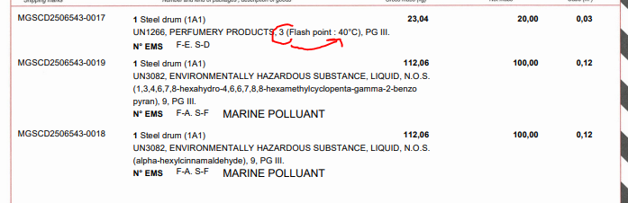
Flash point incorrect
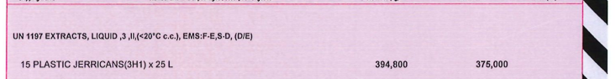
Flash point missing
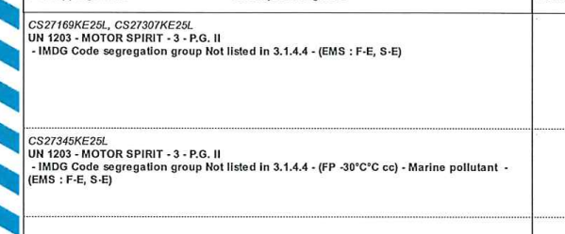
What happens if Flash point is correct : “Flash point Found”
What happens if Flash point is incorrect (>/<) or missing : “Flash point Incorrect or Missing”

- For Class 8, many shipping line request the SEGREGATION GROUP. So the name “SEGREGATION GROUP” should be mentioned on the DGD
What happens if Segregation group is mentionnde on DGD : “SEGREGATION GROUP mentioned”
What happens if Segregation group is NOT FOUNDon DGD: “Segregaton group might be requested by shipping line
What if it is not Class 8 = No message
- MSDS
Document MSDS have title Material Satefy Data Sheet, or Safety Data Sheet in English. Fiche de donnée de sécurité in French. ** Add other languages** They all have 16 paragraphs called SECTIONS.
- Match of the MSDS and the DGD
MSDS always has a SECTION number 14 about TRANSPORTATION of the GOODS. In this SECTION 14 there are several paragraph, can be ADR = for ROAD transport. Can be IATA = for AIR transport. The data we need to look at is the paragraph IMDG = Sea transport.
The MSDS paragraph 14.1 IMDG show the UN number, and 14.2 the Proper shipping name and the 14.3 the Class.
Tool needs to cross check the MSDS in ENGLISH 14.1 and 14.2 match with the data on the DGD.
MSDS in OTHER languages needs to see if 14.1 matchs, (14.2 can not match as it is another language)
Several example of paragraph 14 of a MSDS, with 14.1 and 14.2
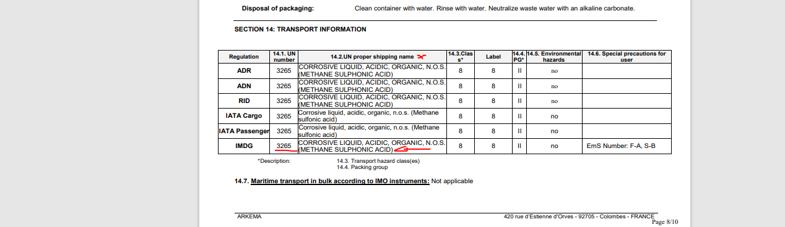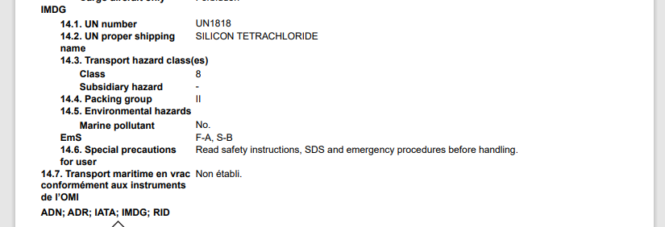

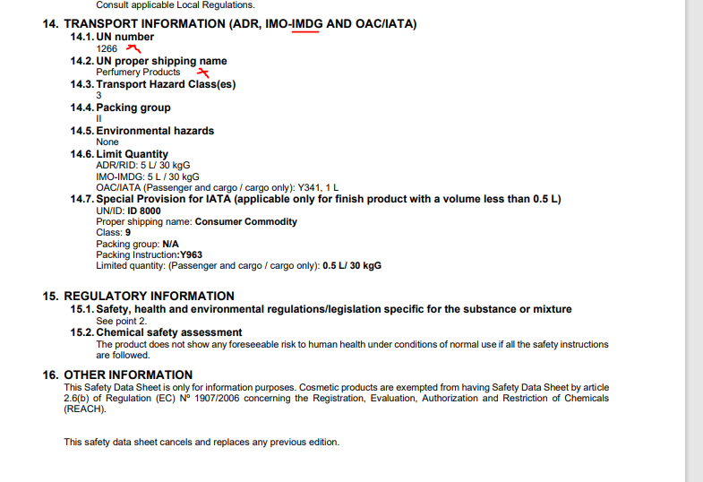
What happens if MSDS found matches with DGD : “MSDS – DGD match found”
What happens if MSDS 14.1 and/or 14.2 don’t match with DGD. For example MSDS says UN 3082 but there is NO UN 3082 on the DGD : “MSDS UN XXXX (Place UN number 14.1) not found on DGD
What happens if DGD don’t have a MSDS that matchs. Example DGD says UN 3082 but none of the MSDS have un 3082: NO MSDS match found with DGD UN number XXXX
What happens if MSDS paragraph 14 don’t have 14.1 and 14.2 : Non hazardous MSDS found
- Validity of the MSDS
First page, first paragraph, the MSDS mention the DATE where the MSDS has been established. This DATE must be < 5 years from today.
What happens if MSDS < 5 years : “MSDS validity checked”
What happens if MSDS > 5 years : Shipping line may request validity of MSDS < 5 years
- List of IMO that are Accepted / refused
We are not shipping line, we are never sure cargo will be accepted 100% sure. It is always under acceptance of warehouses, shipping line and warehouses’s agents at destination. Tool can NEVER say it is accepted. Tool can say when it is REFUSED.

There are 3 excel sheet we share.
One is list of UN number rejected or accepted by ANTWERP WAREHOUSE
One is LIST of UN number rejected or accepted or UPON request by FRANCE warehouses
One is the list of UN number rejected in the past for per destination (Problem is that the PORT list in the EXCEl sheet is not a data on the DGD. User may select the PORT in the tool BEFORE uploading documents) ** That part we need to talk about more deeply what solution is preferable.

If NONE of the Excel sheet says that this UN number for THAT destination PORT is “NOT ACCEPTABLE” or “REJECTED” or “ON REQUEST”, then result says: “UN number not found in a restricted list. Acceptance to be checked on case by case with shipping line”
If at least One of the 3 Excel sheet says NOT ACCEPTABLE or REJECTED or UNDER REQUEST , results say: “Restrictions have been recorded in the past for that UN number (XXXX). Please check further internally

- How should Tool show the result to the user
Example if we provide correct DGD, with correct MSDS and UN number are not restricted, tool should show the following reply to the user:

Presence of Document Checked
Language Checked
Signature Checked
Emergency Phone and Contact checked
Weight Checked:
Mandatory basic Data Checked
Packing Code Found
MSDS – DGD match found
MSDS validity checked
UN number not found in a restricted list. Acceptance to be checked on case by case with shipping line
Important Notice:
This tool performs basic preliminary checks on the Dangerous Goods Declaration (DGD) and Material Safety Data Sheet (MSDS) for consistency and completeness of the use of ECUWORLDWIDE only.
It is NOT a substitute for the IMDG Code, and it does NOT represent acceptance by any shipping line.
- The responsibility for accurate and compliant declaration remains entirely with the shipper (Declarant).
- Shipping lines and carriers may request additional information or documentation beyond what this tool checks.
- This tool is intended only as an elementary first-level review to help identify obvious gaps or inconsistencies.
- Final compliance verification must follow the IMDG Code and carrier requirements.
If carrier / shipping line / agent requests an additional element that this tool has considered as validated, please contact [Name of person in charge of placing Sop for his country + his/her email address]. Your feedback will help us improve the tool and ensure compliance with carrier requirements.
APPENDIX
Appendix 1 : Example 1 LETTER OF ENGAGEMENT (In French LETTRE D’ENGAGEMENT)
Letter needs to be STAMPED 3 times, one time by the Shipping line MARFRET. If it is stamped with ANOTHER shipping line then the Letter is NOT VALID (France ONLY because MARFRET is the shipping line we use, Each other country can use another shipping line)
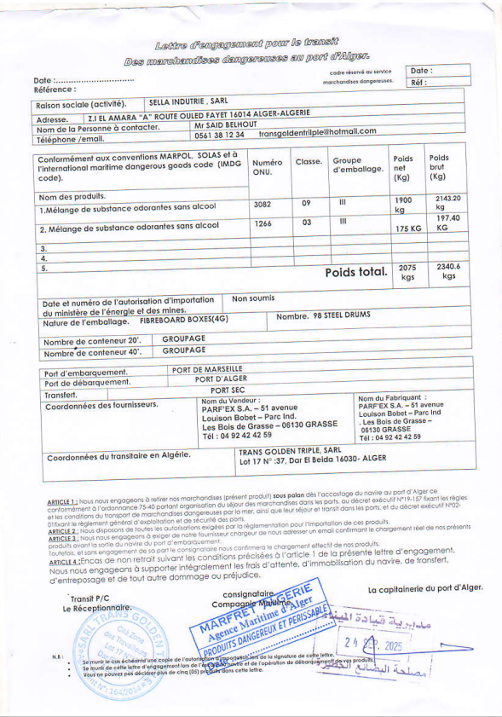

Appendix 2 Example of API (autorisation Prealable d’Importation) document for IVORY COAST
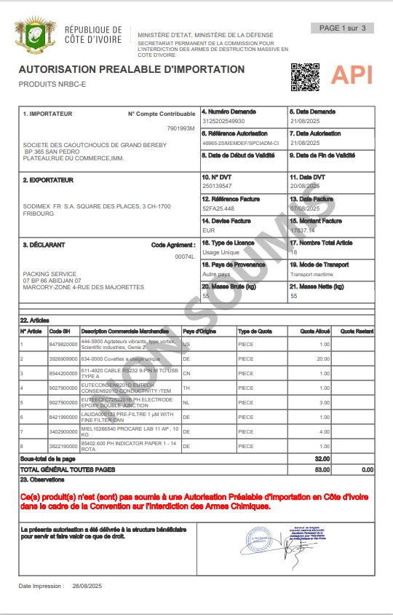

Appendix 3 LETTER OF ENGAGEMENT FOR ABIDJAN (FRANCE ONLY or any other country using shipping line MSC)
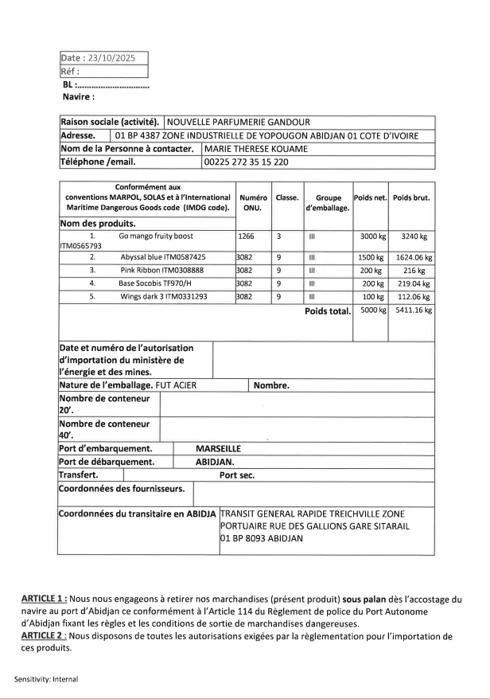
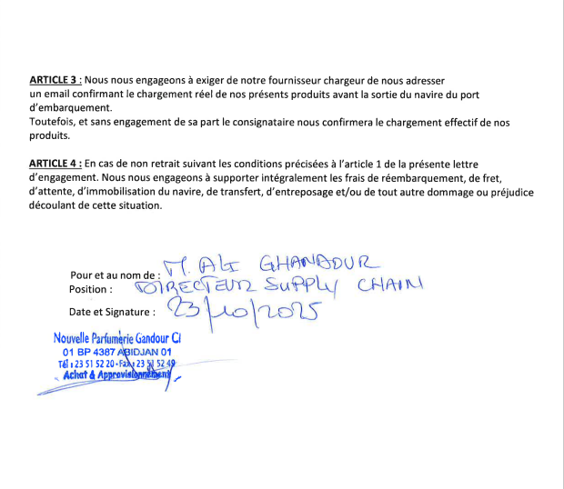
Appendix 4 Example of DGD with 2 languages one is English.

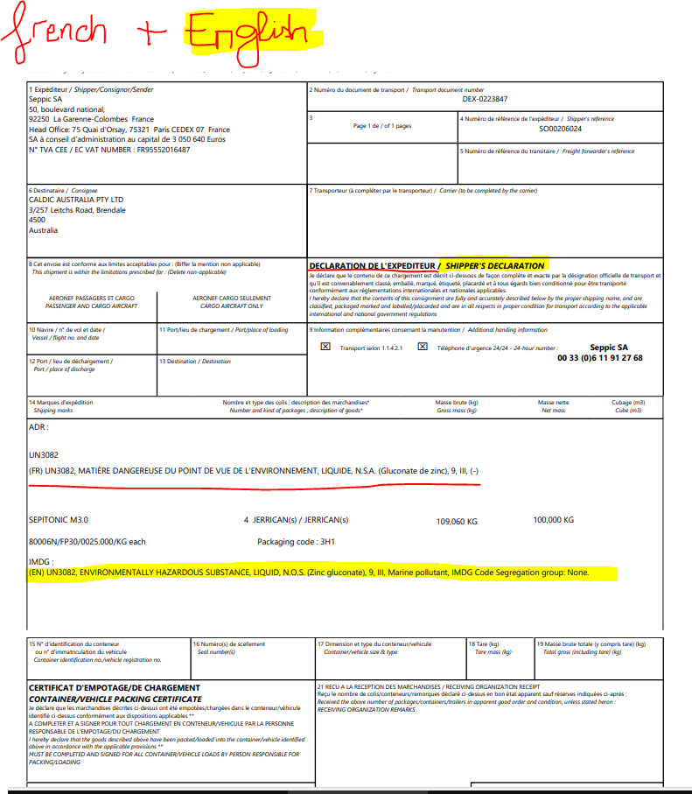

Appendix 5 , list of Existing ONU Packing code (Outturn packing) This is MANDATORY on ALL DGD
These codes are defined in the IMDG Code (Chapter 6.1) and indicate:
- First digit = Type of packaging
- Letter = Material of construction
- Additional digit = Category (e.g., removable head or not)

1 – Drums
- 1A1: Steel, non-removable head
- 1A2: Steel, removable head
- 1B1 / 1B2: Aluminum
- 1D: Plywood
- 1G: Fiber
- 1H1 / 1H2: Plastic
- 1N1 / 1N2: Metal other than steel or aluminum

3 – Jerricans
- 3A1 / 3A2: Steel
- 3B1 / 3B2: Aluminum
- 3H1 / 3H2: Plastic

4 – Boxes
- 4A: Steel
- 4B: Aluminum
- 4C1 / 4C2: Natural wood
- 4D: Plywood
- 4F: Reconstituted wood
- 4G: Fiberboard
- 4H1 / 4H2: Plastic

5 – Bags
- 5H1 / 5H2 / 5H3 / 5H4: Plastic (woven, film)
- 5L1 / 5L2 / 5L3: Textile
- 5M1 / 5M2: Paper multi-wall

6 – Composite Packagings
- Examples:
  - 6HA1: Plastic receptacle in steel drum
  - 6HG1: Plastic receptacle in fiberboard box
  - 6PG1: Glass receptacle in fiberboard box

Appendix 6 INNER PACKING LIST (This is MANDATORY if the OUTTURNB PACKING was BOXES (4….)

Bottles (glass, plastic, metal)
Jars (glass, plastic)
Cans (metal, plastic)
Jerricans (small plastic or metal containers)
Flasks (glass or plastic)
Ampoules (glass, for small quantities)
Plastic receptacles (various shapes)
Metal receptacles (small drums or containers)
Porcelain / Stoneware / Earthenware receptacles
Composite inner packagings (e.g., glass or plastic inside a protective casing)
bags (plastic or textile, often used for solids)
Tubes (plastic or metal, for pastes or semi-liquids)

